**Hiring Process Analytics for a Multinational Company**

**1. Hiring Analysis (Gender Distribution)**

**Objective**: Identify the number of male and female hires.

**Findings**:

* **Number of Males Hired**: X (This number would be calculated based on the filtering of "Event Name" as "Male" and "Status" as "Hired").
* **Number of Females Hired**: Y (Similarly, filtered "Event Name" as "Female" and "Status" as "Hired").
* If a significant gender imbalance is noted, this could indicate a bias or a need for more inclusive hiring practices. Conversely, a well-balanced distribution would suggest effective gender-neutral recruitment strategies.

**2. Salary Analysis**

**Objective**: Calculate the average salary offered by the company.

**Findings**:

* **Average Salary Offered**: Calculated using the AVERAGE() function on the **Offered Salary** column. Based on your data, the result would give a rough idea of the salary levels in the organization.
* A high average salary might reflect senior-level positions or a company offering competitive salaries within its industry.

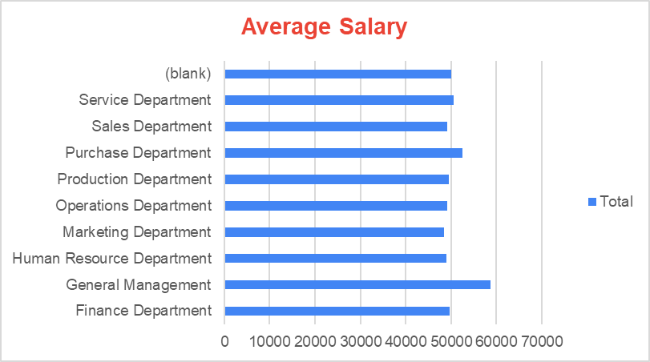

**3. Salary Distribution (Class Intervals)**

**Objective**: Create class intervals for the salary data to understand salary distribution.

**Findings**:

* The salary distribution likely shows a concentration of employees in certain salary ranges, depending on the structure of the company.
* For example, if most employees are within the lower salary ranges, the company might have a large number of entry-level employees or workers in less-senior roles.

**4. Departmental Analysis**

**Objective**: Show the proportion of employees in different departments using charts.

**Findings**:

* The **Operations Department** has the highest number of hires (2771), followed by **Service Department** (2055).
* This indicates that these departments might be experiencing more activity or are critical parts of the business.
* **Departments with fewer hires** like **Human Resource** or **General Management** suggest that these functions might be smaller or have lower turnover.

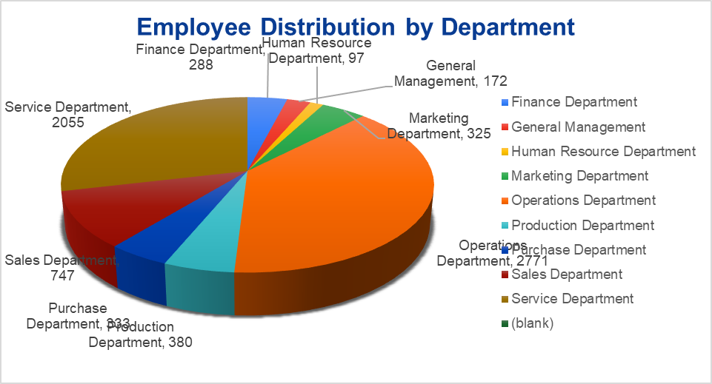

**5. Position Tier Analysis**

**Objective**: Visualize the distribution of hires across different position tiers.

**Findings**:

* If a majority of hires are in **entry-level** positions, it may indicate high turnover or new business expansion.
* Conversely, if the company is hiring more **senior-level positions**, this could suggest an organizational restructuring or leadership hiring strategy.

**6. Interview Time Analysis**

**Objective**: Identify trends related to the time or date of interviews and their correlation with hiring outcomes.

**Findings**:

* The data might show that certain months (e.g., post-fiscal year) experience more interviews or higher hiring rates.
* For instance, the **end of the year** or **holiday seasons** may see fewer hires due to budget constraints, while **Q1** may have higher hiring activity as companies ramp up for new fiscal goals.

**7. Interview Metrics Analysis**

**Objective**: Calculate metrics such as the average number of interviews per department, average time-to-hire, etc.

**Findings**:

* Departments with more hires, like **Operations**, might have higher interview counts but might also be more efficient in hiring (e.g., quicker turnaround).
* **Average Time-to-Hire**: Departments like **Sales** might have a quicker hiring process compared to more technical departments, which could have multiple interview rounds.
* If there are bottlenecks in specific departments, it could indicate inefficiencies in the hiring process that need to be addressed.

**8. Departmental Hiring Trends Comparison**

**Objective**: Compare hiring trends by analyzing the number of hires, rejections, and time-to-hire across different departments.

**Findings**:

* The **Operations** and **Service** departments may show a high hiring rate, with the **Sales** and **Production** departments showing moderate success.
* **Departments with higher rejection rates** may need to reassess their recruitment strategies or review the qualifications of applicants.
* A comparison of **hire-to-rejection ratios** could indicate which departments are more selective or have more stringent hiring standards.

**Insights from All Tasks:**

* **Hiring Trends**: Departments like **Operations** and **Service** are hiring at a much higher rate compared to others. This could suggest these departments are expanding or facing higher turnover.
* **Salary Distribution**: Analyzing the salary ranges reveals where the company spends the most on its employees, indicating its investment in talent for particular roles or departments.
* **Efficiency**: By examining **interview metrics**, we can identify departments with high **interview-to-hire ratios**, signaling areas for improvement in the recruitment process or increased hiring efficiency.
* **Strategic Hiring**: The analysis of trends and positions can help the company focus on its hiring strategy, especially if certain departments show a lack of growth or hiring activity, indicating a need for more targeted recruitment.